EXP:1
Create a Kanban Board to Visualize the Tasks.
- Create Columns for To Do, In-Progress and Done.
- Add Atleast 5 Sample Tasks
- Move the Tasks across the Columns to Simulate the Workflow.

Aim
To create and simulate a Kanban workflow using Jira or Trello.
Procedure
1. Login to Jira/Trello.
2. Create a new Kanban board.
3. Create columns: To Do, In Progress, Done.
4. Add 2 to 3 tasks.
5. Move tasks across columns to simulate workflow.
OUTPUT:
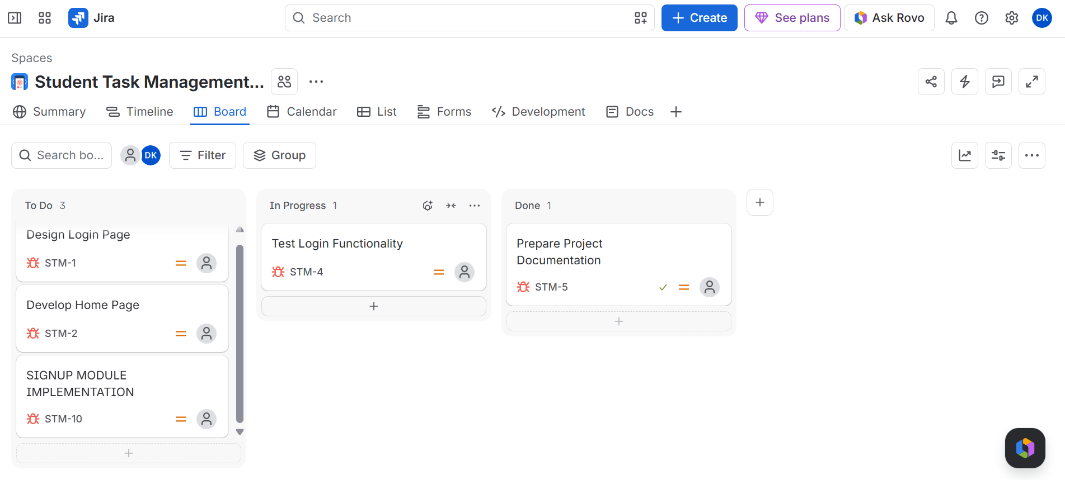
Result: Thus, The Kanban board has created successfully and simulated
workflow by moving tasks across stages.

